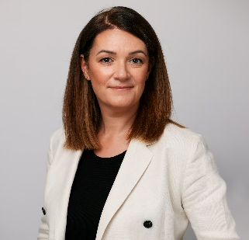  Jennifer Syed  Deputy Head of Region, Asia-Pacific  Adam Smith International | 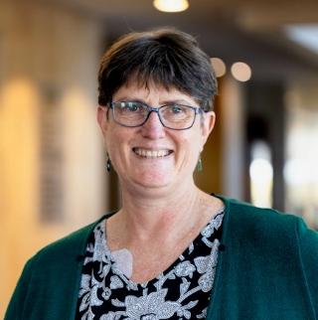  Dr Jennifer Sisson  Dean, Faculty of Travel Medicine, Australian College of Tropical Medicine  Chair, International Society of Travel Medicine’s Travel for Work |  | 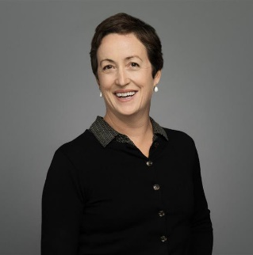  Amy Elleway  Special Counsel, Lexbridge Lawyers  Project Manager & Legal Counsel, National Hydrogen Regulatory Review, Department of Climate Change, Energy, the Environment and Water (DCCEEW), Australian Government
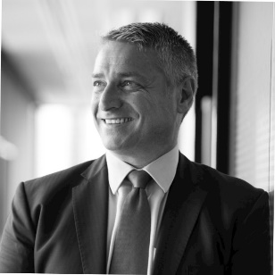  Kevin Zuccato  Member, Forum of Australasian Security Executives (FASE) General Manager Group Security, Australian Post |   Peter Koh  Chair  Global Business Travel Association (GBTA) APAC |  |   Er. Ho Siong Hin  President  International Association of Labour Inspection (IALI)
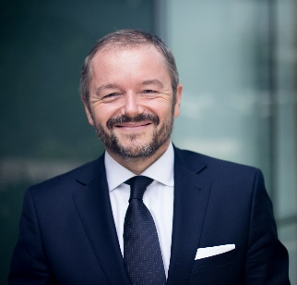  Franck Baron  President  International Federation of Risk & Insurance Management Associations (IFRIMA) | 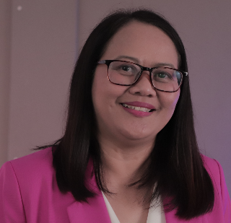  Annacel Natividad  Chairperson  Pan-Asia Risk and Insurance Management Association (PARIMA) |  |   Deborah de Cerff  Founder  The Employee Mobility Institute  (TEMI)
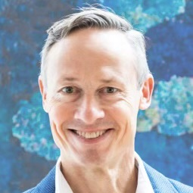  Dr Rob McDonald  Adjunct Professor, Monash University’s Centre for Occupational and Environmental Health  Advisory Council, Turner Institute for Brain & Mental Health |  | 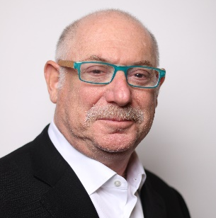  Neil Solomon  VP, Asia-Pacific & Latin America  UKG
<2024 안전배려의무 어워드 심사단>

