Study Summary Article
Efficacy of the VKPro Standalone Room Air Purifier Against a Broad Range of Surrogate Microorganisms

W. Andrew Dexter ª, Richard Ludwick ª, Jamie Balarashti ª
ª Aerosol Research and Engineering Laboratories Inc. Olathe KS

Article Info

Radic8: VKPro
Project Number: 10906.10

Article History:

Submitted: 13th July 2021

Keywords:

- VKPro
- Bioaerosol Reduction
- Pantoea agglomerans
- Aspergillus brasiliensis
- Staphylococcus epidermidis
- Bacillus subtilis
- PhiX-174
- MS2

FDA Compliance:

This study was conducted in compliance with FDA Good Laboratory Practices (GLP) as defined in 21 CFR, Part 58.

Testing Lab:

Aerosol Research and Engineering Laboratories, Inc.
Project #: 10906.10

Conflict of Interest:

Aerosol Research and Engineering Laboratories, Inc. have no affiliations with, or involvement in any capacity, with Radic8’s financial interests such as; membership, employment, stock ownership, or other equity interest.

Other Reference Documents:

This document is one of 8 reports documenting the efficacy of the VKPro. The other 7 reports address each organism individually.

ABSTRACT

Background:
Due to the high rate of infectious disease transmission through aerosol exposure to pathogenic microorganisms, systems designed to reduce the levels of airborne pathogens and other contaminants, in room air have been attracting significant attention. This in-vitro study characterized the efficacy of Radic8’s VKPro, air purification system, to reduce respirable bioaerosol levels for six broad-ranged species of microorganisms from the air in a 16m³ stainless steel bioaerosol chamber. The species selected for this study are recognized surrogates for more dangerous pathogenic organisms. In this study, the species tested were: MS2, a non-enveloped ssRNA virus that is a common surrogate for influenza viruses and is a tentative surrogate for SARS-CoV-2; PhiX-174, a non-enveloped ssDNA virus, that is a surrogate for herpes simplex and smallpox viruses; Methicillin Resistant Staphylococcus epidermidis (MRSE), a gram-positive bacterium that serves as a surrogate for many pathogenic gram-positive bacteria, including Methicillin Resistant Staphylococcus aureus (MRSA); Pantoea agglomerans, previously known as Erwinia herbicola a gram-negative bacterium that is a surrogate for Yersinia pestis; Bacillus subtilis bacterial endospores, which serve as a model for the many bacterial species that produce highly resistant endospores; and the spores from Aspergillus brasiliensis, one of the most common sources of toxic black mold.

This report is for the VKPro, which is one of two devices (VKPro and VKAir) tested for Radic8. This study was done to test the commercial production versions of these two Radic8 models for their efficacy, for air purification, against six organisms. All devices were tested at the highest fan speed.

Methods:
Each microorganism was aerosolized into a sealed 16m³ environmental bioaerosol chamber, containing the Radic8 VKPro, using a Collison 24-Jet Nebulizer or dry powder eductor. All the bioaerosols had a mass median aerodynamic diameter (MMAD) ranging from 0.7-4.0 µm (species dependent). Bioaerosol samples were taken at multiple time points throughout each trial, in order to quantify the reduction rate capability of the air purification device. Impinger samples were serially diluted, plated, incubated, and enumerated in triplicate to yield viable bioaerosol concentration for each sampling point. Chamber control trial data, or natural decay, was subtracted from the device trial data to yield the net LOG reduction for each of the bioaerosol challenges. Additionally viable cascades, run at 30 L/min, were used to further resolve the lower detection limits achieved by the Radic8 device.

Results:
The Radic8 VKPro, on the highest fan speed, was effective at reducing all of the tested bioaerosols by a minimum net log of 4.0 or greater (equivalent to 99.99% reduction) within 90 minutes or less. All of the tested organisms surpassed this threshold by at least 1 log at the end of testing. This report will present test results for all of the tested organisms

Conclusions:
The VKPro is extremely adept at removing bioaerosols from a given room. Within 60 min of operating, the VKPro had removed >4.0 Net Log of Staphylococcus epidermidis and MS2 from the test chamber. Additionally the other tested organisms were removed at >4.0 Net Log at the 90 min mark minus Pantoea agglomerans which took 120 min to reach the >4.0 Net Log reduction. Given the level of reduction of these organisms, conclusions can be drawn about how is device would work against more dangerous pathogens the have similar characteristics to our surrogate test organisms.

Introduction

This study was conducted to evaluate the efficacy of the VKPro room air purifier, manufactured by Radic8, at reducing aerosolized bio organisms. The VKPro device is a free standing air filtration device, equipped with UV-C LEDs and a true HEPA filter. It is designed to reduce a broad range of gram-positive and gram-negative bacteria, RNA and DNA viruses including SARS-CoV-2, bacterial fungal spores, and other airborne contaminants in room air. The VKPro device is designed for medical purposes in medical facilities and other indoor spaces. The test plan incorporated challenging the VKPro, in a closed environmental chamber, to determine the reduction rate of two separate aerosolized viruses, two separate aerosolized bacteria, and two types of spores. A picture of the VKPro device is shown in Figure 1. This report will focus on the efficacy of the VKPro to remove a broad range of organisms from the air.

Study Overview

The effectiveness of the VKPro was evaluated against an RNA virus, a DNA virus, a gram negative bacteria, a gram positive bacteria, a spore forming bacteria, and a mold spore.

Testing was conducted to characterize the reduction efficacy of a single VKPro unit against six aerosolized micro-organisms. This will allow for a reasonable demonstration of the capability of the VKPro device, when operating at its highest fan speed, to reduce viable bioaerosol concentrations and therefore theoretically reducing the chances of exposure to airborne pathogens.

Previous R&D testing

Previous testing of Radic8 devices has been conducted by ARE labs over the course of several months. Initial testing concluded a high efficiency of bioaerosol removal from the 16m³ bioaerosol chamber. Once this testing was complete, the testing proceeded for all six species on the highest fan speed of the VKPro device.

Test Device Description

The VKPro is a standalone air purification system with two separate filtration trays. Both of these are equipped with multi-step filtration including a pre-filter, carbon filter and HEPA filter. Additionally, the VKPro has 8 UV-C lamps and 70 TiO₂ hextubes for further photocatalytic oxidation purifying power. The UV-C increases the decontamination efficacy. It also self-decontaminates internal components in addition to facilitating the photocatalytic oxidation reaction. The pre-filter, which is used to captures large dust particles and other debris, is followed by an activated carbon filter intended to remove volatile organic compounds (VOC’s). An integrated High Efficiency Particulate Air (HEPA) filter removes respirable particles (<0.3 µm). The hextubes and UV-C technology is intended to degrade any biological organisms that may have passed through the filters using high intensity UV-C light. The device is equipped four blower speeds, and is designed for rooms of 100 m² with a standard ceiling height of 2.4 m. The device was tested on its highest fan speed, in the middle of the testing chamber for the duration of all the testing.

Bioaerosol Testing Chamber

A 16m³ sealed aerosol test chamber was used to replicate a contaminated room environment and to contain any potential release of aerosols into the surrounding environment.
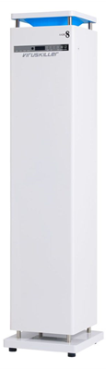
Figure 1: VKPro Device: HEPA with UV-C and hextubes technology. Integrated pre-filter and carbon filter for further polishing of treated air. Multi-speed capable of 200-358 CFM flowrate.

The aerosol test chamber is constructed of 304 stainless steel and is equipped with three viewing windows and an air-tight lockable chamber door for system setup and general ingress and egress. The test chamber internal dimensions are 9.1 ft x 9.1 ft x 7 ft, with a displacement volume of 579 cubic feet, or 16,000 liters. Figure 2 shows the bioaerosol chamber used for all testing in this study.

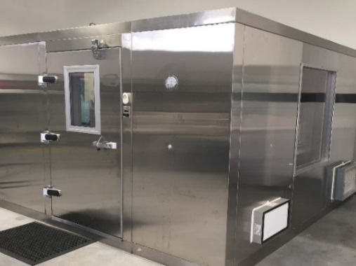

Figure 2: Stainless Steel Bioaerosol Test Chamber used for all VKPro Testing. Chamber is equipped with HEPA in/out, multiple bio aerosol sampling ports, decontamination and pressure balance. Exterior picture.

The chamber is equipped with filtered HEPA inlets, digital internal temperature and humidity monitor, external humidifiers, lighting system, multiple sampling ports, aerosol mixing fans, and a HEPA filtered exhaust system that are operated with wireless remote control. For testing, the chamber was equipped with four 3/8-inch diameter stainless steel probes for aerosol sampling, a 1-inch diameter port for

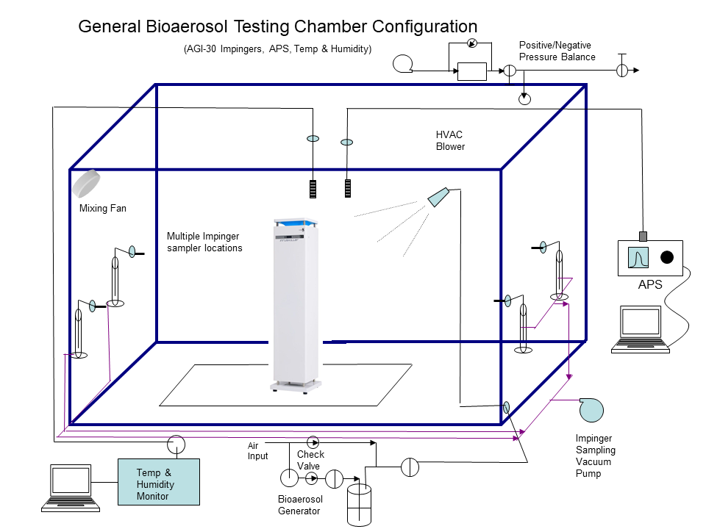
Figure 3: Bio-Aerosol Test Chamber Flow Diagram. Chamber includes bioaerosol induction, multiple bioaerosol sampling ports, Particle size monitoring, internal mixing fans, temperature and humidity controls. Main system HEPA Evacuation System not pictured.

bio-aerosol dissemination into the chamber using a Collison 24-jet nebulizer or dry powder eductor for the aerosolization of the microorganisms and spores, respectively.

In order to avoid wall effects, all sample and dissemination ports were inserted approximately 18 inches in from the interior walls of the chamber and at a height of approximately 40 inches from the floor to avoid wall effects. The aerosol sampling and aerosol dissemination probes are stainless steel and bulk headed through the chamber walls to provide external remote access to the aerosol generator and samplers during testing. The test chamber is equipped with two high-flow HEPA filters for the introduction of filtered purified room air into the test chamber during aerosol evacuation/purging of the system between test trials. A HEPA filtered exhaust blower, with a 500 ft³/min rated flow capability, is used for rapid evacuation of remaining bioaerosols. A Magnehelic gauge with a range of -0.5 to 0.5 inches of H₂O (Dwyer instruments, Michigan City IN) is used to monitor and balance the system pressure during aerosol generation, aerosol purge, and testing cycles.

Environmental Controls

For increased stability of bioaerosols, relative humidity

inside the chamber was kept at 65% +/- 5% using a PID humidity controller in combination with an ultra-sonic humidifier to nebulize filtered DI water. Temperature controls maintain chamber trial conditions at typical ambient conditions of 74°F +/- 2°F

Bioaerosol Generation System

All test bioaerosols were disseminated using a Collison 24-jet nebulizer (BGI Inc. Waltham MA), similar to the one shown in Figure 4, with the exception of the A. brasiliensis spores which were aerosolized using a dry powder eductor. The aerosolization of bioaerosols were driven by purified, filtered house air supply. A pressure regulator allowed for control of disseminated particle size, use rate, and sheer force generated within the Collison nebulizer. Prior to testing, the Collison nebulizer flow rate and use rate were characterized using an air supply pressure of approximately 40-60 psi, which produced an output volumetric flow rate of 50-80 L/min with a fluid dissemination rate of approximately 1.25 mL/min. The Collison nebulizer was flow characterized using a calibrated TSI model 4040 mass flow meter (TSI Inc., St Paul MN).

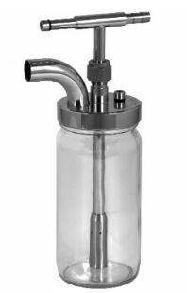
Figure 4. 6-Jet Collison nebulizer. Glass and 304 stainless steel construction, BGI Industries.

Bioaerosol Sampling and Monitoring System

Two AGI-30 impingers (Ace Glass Inc. Vineland NJ) were used for bioaerosol collection to determine chamber concentrations. The two AGI-30 Impingers were placed at opposite corners of the chamber in order to represent an entire room sample. The mixing fans inside the chamber worked to ensure a homogenous air mixture inside the chamber.

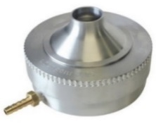
Figure 5: SKC Single Stage BioStage Viable Cascade Impactor used for bacterial and spore sampling for select time points during bioaerosol trials. LOD is >0.01 cfu/L.

The AGI-30 impinger vacuum source was maintained at a negative pressure of 18 inches of Hg during all characterization and test sampling to assure critical flow conditions. The AGI-30 impingers sample at a rate of 12.5 LPM impinger flows were characterized using a calibrated TSI model 4040 mass flow meter. A general flow diagram of the aerosol test system is shown above in Figure 3.

During testing with less resilient organisms, or those which fall out of the air more easily, sample collections were also obtained using a pair of viable cascade impactors. A viable cascade impactor (SKC Inc., Valley View, PA) is comprised of an inlet cone, a precision-drilled 400-hole impactor stage, and a base that holds a standard-size agar plate (Figure 5). A high flow pump pulls microorganisms in the air through the holes (jets) at 30 liters per minute, where they are collected directly onto the agar surface. This method is the most sensitive for the detection of organisms at low concentrations.

TSI Aerodynamic Particle Sizer

A TSI model 3321 Aerodynamic Particle Sizer (APS) (TSI Inc., Shoreview, MN) was used to measure aerosol concentrations and particle size during the test trials. The APS provided real-time aerodynamic particle characterization with a size range from 0.54-20.0 µm with 52 size bins of resolution. Sampling is continuous with a data export interval of 1 second. The APS has a continuous flow rate of 5 liters per minute (LPM). A picture of the APS is shown in Figure 6.

Species Selection
Due to safety concerns for bioaerosol testing, organism selection was based on Biological Safety Level 1 (BSL1) species which served as surrogates for more dangerous pathogenic (BSL2 & BSL3) organisms.
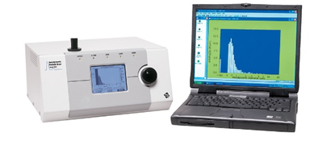
Figure 6. TSI Aerodynamic Particle Sizer (APS) model 3321 used to measure total particle concentration and particle size distribution of the challenge bioaerosol. Range 0.54-20.0 µm aerodynamic diameter, with 1 particle/L detection limits.
Viral Challenges:
MS2 bacteriophage is a viral single-stranded, non-enveloped RNA bacteriophage that has historically been used as a surrogate for influenza viruses. MS2 has also recently been used as a tentative surrogate for SARS-CoV-2 in numerous published bioaerosol studies. PhiX-174 (Φ-X174) is a viral, single-stranded, non-enveloped, DNA bacteriophage traditionally used as a surrogate for viral species such as herpes simplex and smallpox.
The US FDA guidance document, Enforcement Policy for Sterilizers, Disinfectant Devices, and Air Purifiers During the Coronavirus Disease 2019 (COVID-19) Public Health Emergency, states that lipid enveloped viruses, such as coronaviruses, are the least resistant microorganisms to disinfectants. It is presumed that this susceptibility is similar for other chemical, physical and catalytic methods of destruction.

MS2 and Phi X174 are non-enveloped viruses, which makes them more resistant to disinfection than lipid viruses, and therefore, should represent a “worst case scenario” when compared to actual lipid-enveloped RNA viruses like SARS-CoV-2. Figure 7 is a graphic from the FDA document, COVID Sterilizers, Disinfectant Devices, and Air Purifiers Guidance, demonstrating resistance to disinfection.

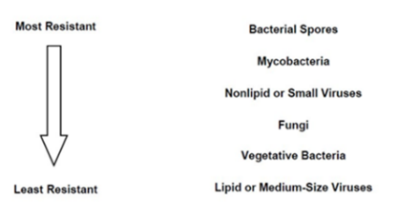
Figure 7: FDA graphic demonstrating general resistance to disinfection for various microorganisms. FDA, Guidance Enforcement Policy for Sterilizers, Disinfectant Devices, and Air Purifiers During the Coronavirus Disease 2019 (COVID-19). Pg. 7. March 2009. SAR-CoV-2 (lipid or medium-Sized Virus), MS2 (non-lipid small virus).

For UV-C deactivation, MS2 is also a much more resilient organism than SARS-CoV-2. To achieve a 1 LOG deactivation of MS2 it takes 15.9 mJ/cm² of UV irradiation (Wilson et al 1992), SARS-CoV-2 takes 3.7mJ/cm² (Heßling et al 2020).
These results were obtained by investigations on many different coronaviruses, including SARS-CoV and MERS-CoV, but not SARS-CoV-2. Nevertheless, it can be assumed that they are also applicable for SARS-CoV-2 and all future mutations. RNA mutations might have a strong influence on the pathogenicity of a virus, but they do not result in larger structural differences, especially concerning the UV absorption properties of the RNA, which are the main cause for the antiviral effect of ultraviolet radiation.
Vegetative Bacteria Challenges:

The vegetative bacteria organisms used for this study included Methicillin Resistant Staphylococcus epidermidis (MRSE) (ATCC 12228). Staphylococcus epidermidis is a gram-positive bacterium and BSL1 simulant for a wider range of medically significant pathogens including Methicillin Resistant Staphylococcus aureus (MRSA).

Escherichia coli was selected as a gram-negative vegetative bacterium for this study. (ATCC 15597). E. coli is a bacterium commonly used in various forms of testing as it is a common pathogen found in a multiplicity of places, and it can survive on many surfaces, and it may cause serious illness (potentially lethal) itself.

Pantoea agglomerans was selected as a gram-negative vegetative bacterium for the study (ATCC 33261). Previously known as Erwinia herbicola, has served as a black plague (Yersinia pestis) surrogate. This organism is a plant pathogen that is fairly common and abundant naturally.

Mold Spores and Bacterial Endospore Challenges:

Aspergillus brasiliensis (ATCC 16404), formerly known as A. niger, is one of the most common species of the genus Aspergillus. A. brasiliensis is routinely defined as a surrogate for various toxic black mold species such as Stachybotrys chartarum. Many respiratory problems found in infants, the elderly and immunocompromised individuals are attributed to mold. Purified A. brasiliensis spores were used in bulk, dry powder form with an approximate concentration of 1 x 10⁹ cfu/gram.

Bacillus subtilis (ATCC 49760), endospores were used as a surrogate for Bacillus anthracis (Anthrax), a biological agent used for bioterrorism/bio warfare research. It also serves as a surrogate for other pathogenic endospore forming species such as Clostridioides difficile, a common and difficult to eliminate hospital pathogen. Bacillus subtilis, a sub-species of Bacillus atrophaeus, is a gram-positive bacterium found in soil and in the gastrointestinal tract of ruminants and humans. B. subtilis is rod-shaped, and forms a tough, highly resistant endospore, which allows it to tolerate extreme environmental conditions.

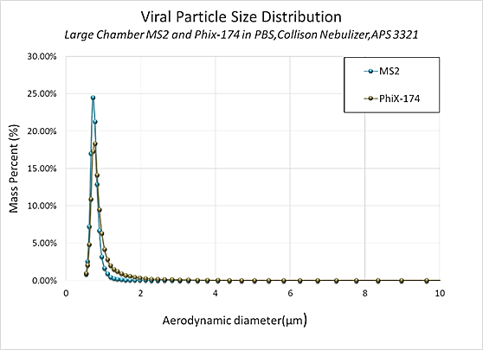
Figure 8: Aerodynamic Particle Size Distribution of RNA virus MS2 and DNA virus PhiX 174 in the test chamber. MMAD for both viral species averaged approximately 0.7 µm.

Bioaerosol Challenge Particle Size Testing

Bioaerosol challenge particle size distributions were measured with a TSI Aerodynamic Particle Sizer model 3321 (APS) for all challenge species. The particle size distribution was taken shortly after aerosolization for each species via sampling through a sample probe into the test chamber. The APS has a dynamic measurement range of 0.54 to 20.0 μm and was programmed to take consecutive real-time one-minute aerosol samples. Data was logged in real-time to an Acer laptop computer, regressed, and plotted.

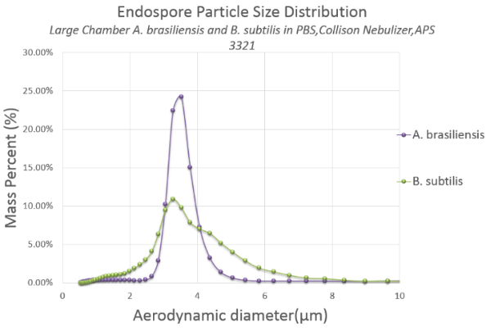
Figure 9: Aerodynamic Particle Size Distribution of P. agglomerans in the test chamber. MMAD for each species was approximately 1-3 µm.

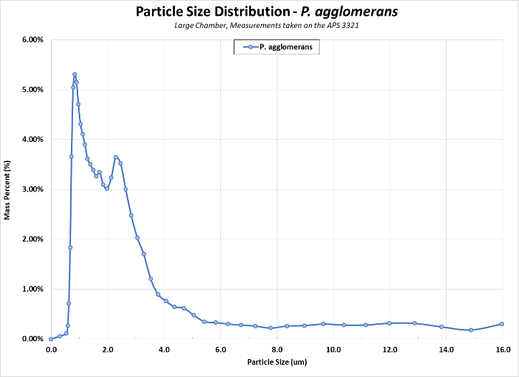
Figure 10: Aerodynamic Particle Size Distribution of P. agglomerans in the test chamber. MMAD for each species was approximately 1-3 µm.

The aerodynamic particle size distribution for all challenge bioaerosols are shown to be within the respirable range for regional alveolar tract deposition and show a low geometric standard deviation (GSD), indicating that a monodispersed aerosol was generated in the chamber for each of the challenge species. The aerodynamic particle size distributions for MS2 and Phi X174 can be found in Figure 8, shown above.

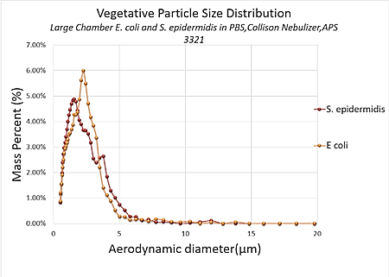
Figure 11: Aerodynamic Particle Size Distribution of S. epidermidis and E. coli in the test chamber. MMAD for each species was approximately 2.4-2.6 µm.

Viral Culture & Preparation

Pure strain viral seed stock and host bacterium were obtained from ATCC. Host bacterium was grown in a similar fashion to the vegetative cells in an appropriate liquid media. The liquid media was infected during the logarithmic growth cycle with the specific bacteriophage.

After an appropriate incubation time, the cells were lysed and the cellular debris separated by centrifugation. MS2 stock yields were greater than 1 x 10¹¹ plaque forming units per milliliter (pfu/mL) with a single amplification procedure. This stock MS2 viral solution was then diluted with PBS to approximately 1 x 10¹⁰ plaque forming units per milliliter (pfu/mL) for use in the Collision nebulizer. The Phi X174 stock was prepared in the same manner however, in order to achieve a high enough concentration the Phi X 174 underwent a double amplification procedure.

Vegetative Cells Culture & Preparation

Pure strain seed stocks were purchased from ATCC (American Type Culture Collection, Manassas VA). For ATCC reference numbers see Table 1 below on page 8. Working stock cultures were prepared using aseptic techniques in a class 2 biological safety cabinet and followed standard preparation methodologies. Approximately 250mL of each biological stock was prepared in tryptic soy liquid broth media, and incubated for 24-48 hours with oxygen infusion (1cc/min) at 37°C. Biological stock concentrations were around 1 x 10¹⁰ cfu/ml.

Stock cultures were centrifuged for 10 minutes at 3000rpm in an LD-3 centrifuge in sterile 15mL conical tubes, growth media was removed, and the cells re-suspended in sterile PBS buffer for aerosolization. Aliquots of these suspensions were enumerated on tryptic soy agar plates (Hardy Diagnostics, Cincinnati OH) for viable counts and stock concentration calculation. For each organism, test working stocks were grown in sufficient volume to satisfy use quantities for all tests conducted using the same culture stock material.

Fungal Spore Culture & Preparation

Aspergillus brasiliensis fungal spores were obtained in purified bulk powder form at a concentration of 1 x 10⁹ cfu/g. To verify the bulk powder spore concentration, an aliquot of weighed dry powder was prepared in suspension in PBS + 0.005% Tween 80 at a mass: volume ratio to obtain a concentration of 1 x 10⁹ cfu/ml. This aliquoted spore suspension was plated prior to testing to verify concentration.

Bacillus subtilis freeze-dried spores were purchased from ATCC with a stock concentration of 1 x 10¹¹ cfu/gram. One gram of dry spores was suspended in a 250mL solution

Table 1: Test Matrix for the Radic8 VKPro purification

of 50/50 91% Isopropyl alcohol and PBS + 5% Tween to assist in de-agglomeration. This suspension was sonicated for 40 minutes in order to bring all powder into solution. This aliquoted spore suspension was plated prior to testing to verify concentration.

Plating and Enumeration

Impinger and stock biological cultures were serially diluted and plated in triplicate. (Multiple serial dilutions) using a standard spread plate assay technique onto tryptic soy agar plates. The plated cultures were incubated for 24-48 hours, depending on the species, then enumerated and recorded

When working with microorganisms at extremely low concentrations viable cascade sampling was used. This method samples the chamber by pulling 30 liters per minute through the cascade device directly onto an agar plate. Enumeration of colonies grown depends on the concentration of the sample. Colony counts, totaling up to 400, can then be adjusted using the positive conversion table. This table is based on the principle that, as the number of viable particles being impinged on a given plate increases, the probability of the next particle going into an “empty hole” decreases. This can be corrected statistically using the conversion formula of Feller, W (1950).

Post-Testing Decontamination and Prep

Following each test, the chamber was air flow evacuated/purged for a minimum of twenty minutes between tests and analyzed with the APS for particle concentration decrease to baseline levels between each test. The chamber was decontaminated at the conclusion of the trials with aerosol/vaporous hydrogen peroxide (35%). The Collison nebulizer and impingers were cleaned at the conclusion of each day of testing by soaking in a 3% bleach bath for 20 minutes. The nebulizer and impingers were then submerged in a DI water bath, removed, and spray rinsed 6x with filtered DI water until use.

Data Analysis

Results from the control trials were graphed and plotted to show natural viability loss over time in the chamber. These control runs served as the basis to determine the time required for the VKPro device to achieve at least a 4 LOG (99.99%) reduction in viable bioaerosol above the natural losses from the control runs. The control and trial runs are plotted showing log reduction in viable bioaerosol for each organism. All data is normalized with time zero enumerated concentrations. Subsequent samples are normalized and plotted to show the loss of viability over time

Methods: Bioaerosol Efficacy Testing

To accurately assess the VKPro unit, test chamber pilot control trials were performed with all organisms over a 120-minute time period to characterize the biological challenge aerosol delivery/collection efficiency, and viable concentration over time. Control testing was performed to provide baseline comparative data in order to assess the actual reduction from the VKPro challenge testing and verify that viable bioaerosol concentrations persisted above the required concentrations over the entire pilot control test period. During control runs, a single low velocity fan, located in the corner of the bioaerosol test chamber was turned on for the duration of the trial to ensure a homogenous aerosol concentration within the aerosol chamber. The mixing fan was used for all control runs and was turned off during VKPro decontamination trials. The two impingers used for bioaerosol collection were pooled and mixed prior to plating and enumeration. A complete test matrix for the bioaerosol trials can be found in Table I above.

For each control and challenge test, the Collison nebulizer was filled with approximately 40 mL of biological stock and operated at 40 psi for a period of 20 minutes. Then, the impingers were filled with 20 mL of sterilized PBS with an addition of 0.005% v/v Tween 80 for bioaerosol collection. The addition of Tween 80 was used in order to increase the impinger collection efficiency and de-agglomeration of all microorganisms. The chamber mixing fan was turned on during bioaerosol dissemination to assure a homogeneous bioaerosol concentration in the test chamber prior to taking the first impinger sample (T=0).

Following bioaerosol generation, baseline bioaerosol concentrations were established for each pilot control and VKPro test by sampling simultaneously with two AGI-30 impingers located at opposite corners of the chamber. The samples were collected for 3 to 20 minutes at intervals of 15 or 30 minutes throughout the entire test period.

Collected impinger chamber samples were pooled and mixed at each sample interval for each test. Aliquots of impinger samples were collected and then used for plating. Impingers were rinsed 6x with sterile filtered water between each sampling interval, and re-filled with sterile PBS using sterile graduated pipettes for sample collection. During the final 2-3 time points, a viable cascade was used to further increase the limits of detection for the testing.

For VKPro biological testing, the unit was turned on immediately following a time 0 (T=0) baseline sample and operated for the entirety of the test. Subsequent impinger samples were taken at various time points throughout the trial. These samples were enumerated for viable concentration to measure the effective viable bioaerosol reduction during operation of the VKPro device over time.

All samples were plated in triplicate on tryptic soy agar media over a minimum 3 log dilution range. Plates were incubated for 24-48 hours and enumerated for viable plaque forming units (pfu) or colony forming units (cfu) to calculate aerosol challenge concentrations in the chamber and reduction of viable microorganisms.

Results:

This study was performed to evaluate the VKPro device efficacy at reduction of bioaerosols in a controlled room. Reduction of viable bioaerosols by 4 logs, or 99.99%, is the minimum requirement for FDA approved use. The species of microorganisms were selected specifically for their ability to gauge the device’s efficacy for reducing the most commonly encountered organisms.

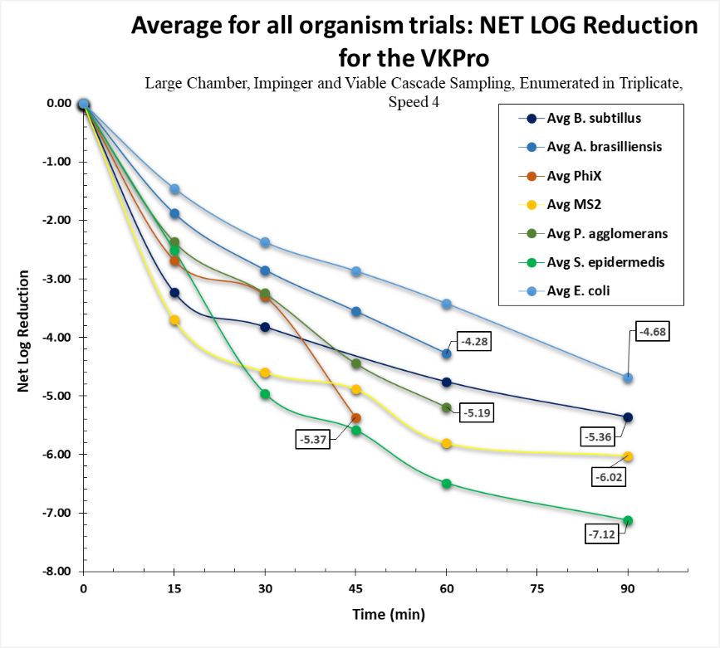
Figure 12: Net LOG Reduction for the VKPro All Organisms Summary Data

When tested against the MS2 bacteriophage, the device showed a net log reduction of 6.02 +/- 0.1 in 15 minutes. When tested against Phi X 174 the device achieved a net log reduction of 5.37 +/- 0.2 in 35 minutes. When tested against
Staphylococcus epidermidis the device reached a net log reduction of 7.12+/- 0.14 in 20 minutes. The other bacterial species tested P. agglomerans reached 5.19 +/- 0.18 in 35 minutes. The Aspergillus brasiliensis spores showed an average net reduction of 4.28 +/- 0.14 net log in 60 minutes. The bacterial endospore from Bacillus subtilis reached a net log reduction of 5.36+/- 0.06 net log in 45 minutes. Net log reduction data can be found above in Figure 12 and below in Table 2.

Conclusions:

Overall, the High fan speed yielded consistent reduction throughout testing, reaching a 4 net log reduction for all species. The duration of time needed to reach a 4 net log reduction varied from 15 to 70 minutes.

Deviations and Acceptance Criteria:

No deviations from the protocol were noted throughout the test trials. Because of the nature of the data and the normal variation, there was no need to perform statistical analyses. All final endpoints were ≤0.30 standard deviations from the mean. In accordance with ARE Labs standard practices, and in compliance with GLPs, all data were verified for accuracy.

Overall Study Summary:

In conclusion, the VKPro device achieved a >4 net log reduction of all bioaerosols within a relatively short period of time. The device proved to be highly effective in reducing the viability of a broad range of aerosolized microbial species. It is anticipated that such a reduction should reduce the likelihood of individuals being exposed to and contracting airborne infectious diseases in any enclosed environment, medical or otherwise. Given a higher starting concentration and longer trials, it is safe to assume that a 6 net log reduction is achievable for all organisms.

Table 2: Executive Summary Data for All Organisms Average of Triplicate Testing for Each Organism

References

Feller, W. (1950). An introduction to probability theory and its applications. Wiley.

T. Reponen, K. Willeke, V. Ulevicius et al. Techniques of Dispersion of Microorganisms in Air. Aerosol Science and Technology. 27: 1997. pp. 405-421.

Ding and Wing. Effects of Sampling Time on the Total Recovery rate of AGI-30 Impingers for E. coli. Aerosol and Air Quality Research, Vol. 1, No. 1, 2001, pp. 31-36.

U.S. Department of Health and Human Services Food and Drug Administration. Enforcement Policy for Sterilizers, Disinfectant Devices, and Air Purifiers During the Coronavirus Disease 2019 (COVID-19) Public Health Emergency Guidance for Industry and Food and Drug Administration Staff. March 2009

Analytical Testing Facility

Aerosol Research and Engineering Labs, Inc.
15320 S. Cornice Street
Olathe, KS 66062

Project #

10893.20

Study Director

Jamie Balarashti
Aerosol Research and Engineering Laboratories

GLP Statement

We, the undersigned, herby certify that the work described herein was conducted by Aerosol Research and Engineering Laboratories in compliance with FDA Good Laboratory Practices (GLP) as defined in 21 CFR, Part 58.

Conflict of Interest Statement

Aerosol Research and Engineering Laboratories, Inc. have no affiliations with, or involvement in any capacity, with Radic8’s financial interests such as; membership, employment, stock ownership, or other equity interest.

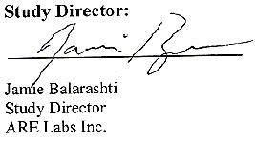
Study Director:

7/14/2021
Date

_________________________ __________
Jamie D. Balarashti Date
Study Director
ARE Labs, Inc.

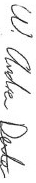

Principal Investigator:

7/14/2021
Date

W. Andrew Dexter M.S.
Staff Research Scientist
ARE Labs, Inc.

APPENDIX A: Additional Figures

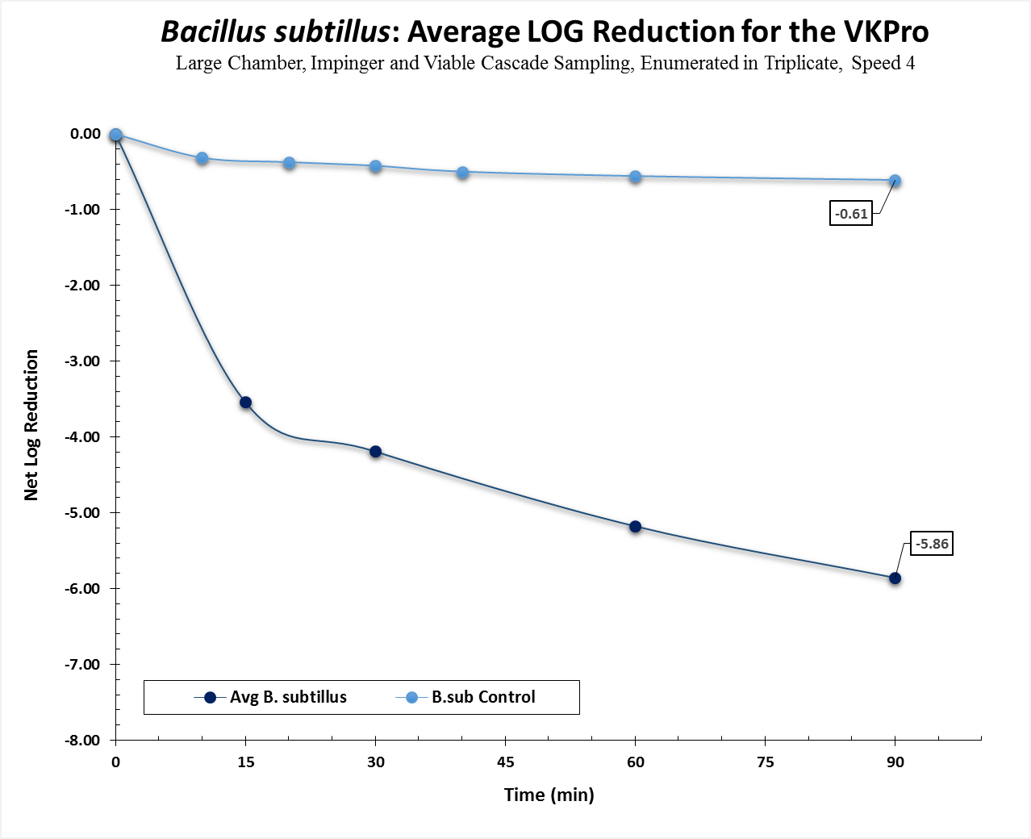
Figure 1A: Average LOG Reduction for Bacillus Subtillus Trials with Control Trial Data

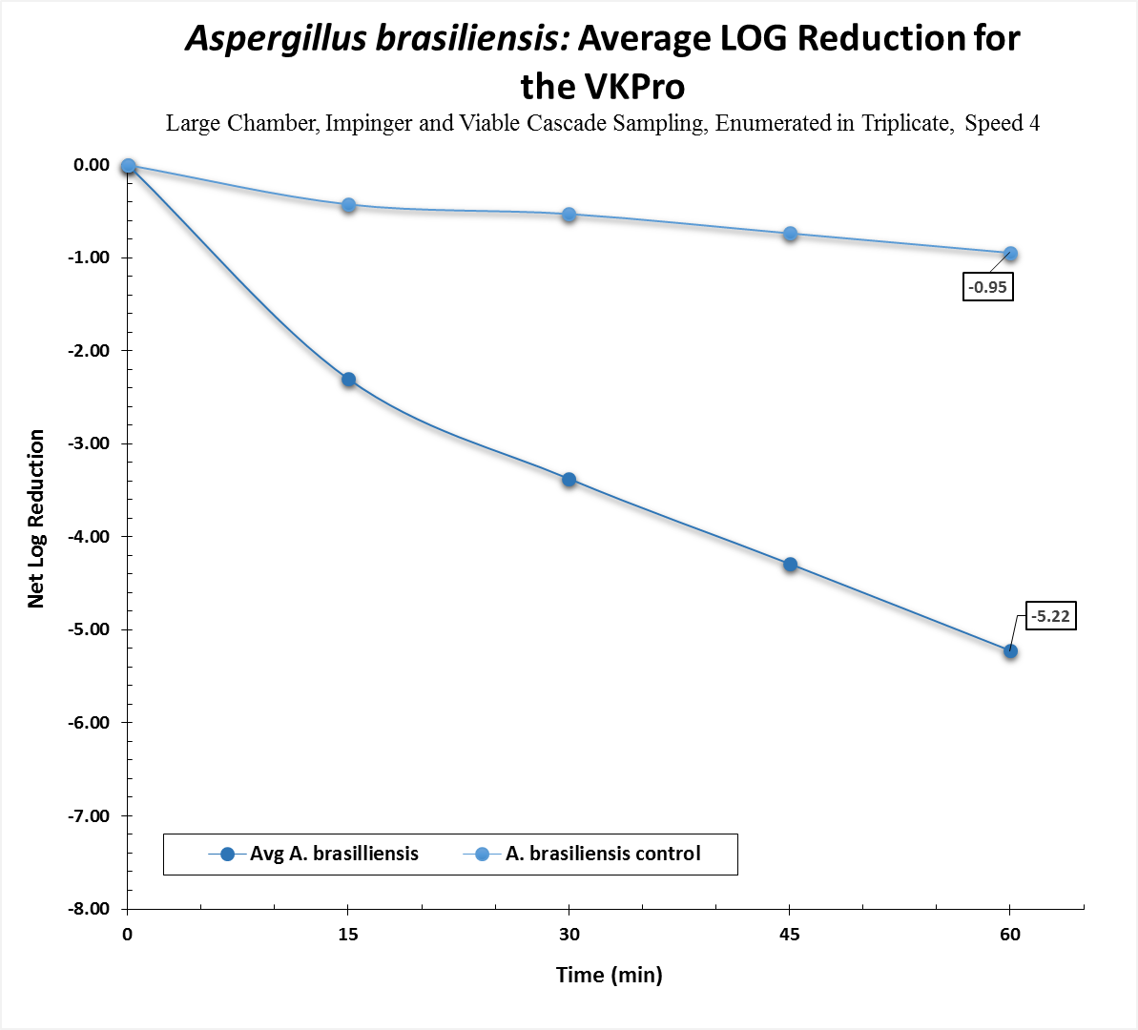
Figure 2A: Average LOG Reduction for Aspergillus Brasiliensis Trials with Control Trial Data

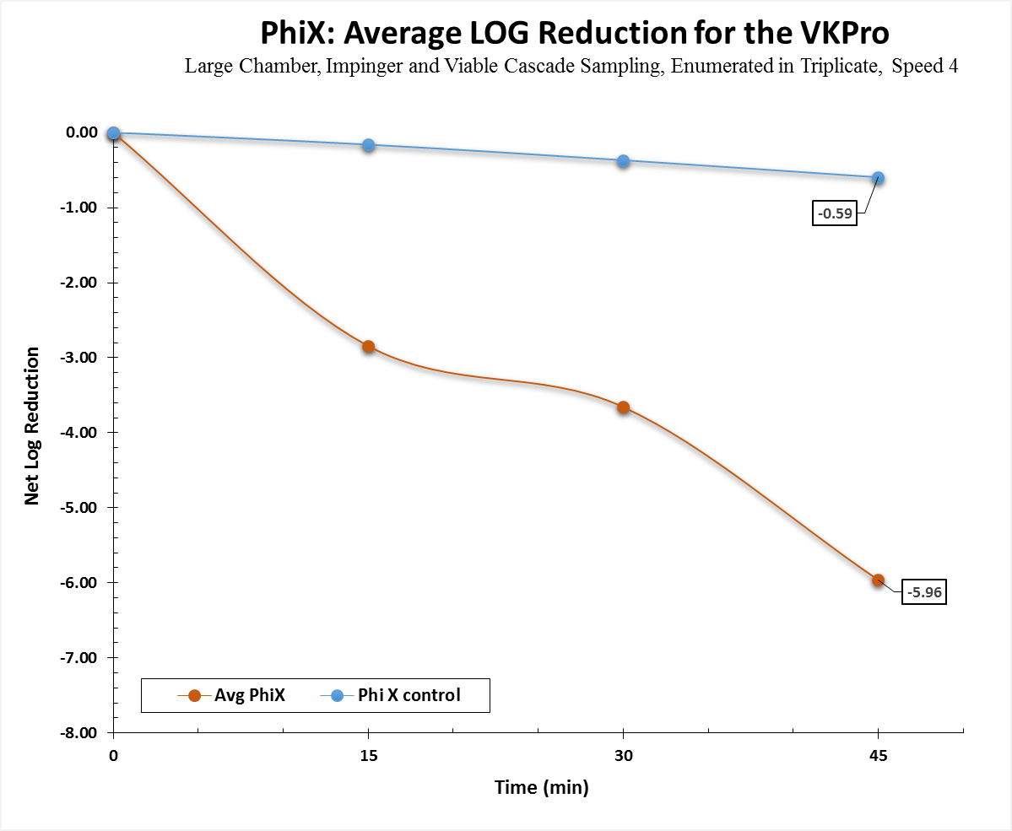
Figure 3A: Average LOG Reduction for PhiX Trials with Control Trial Data

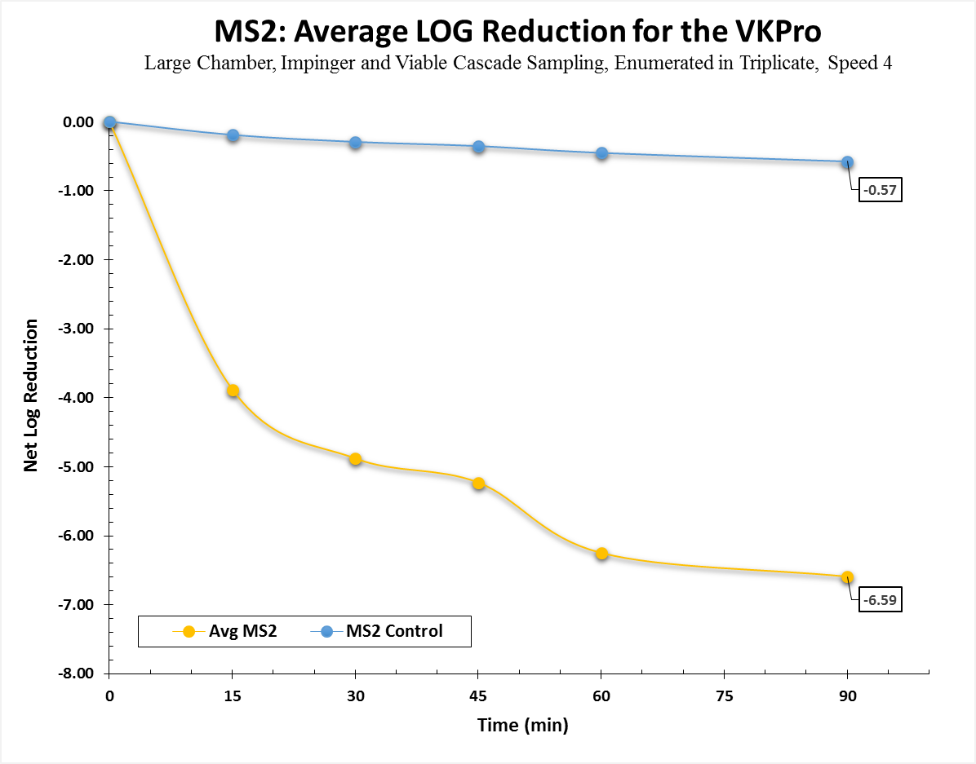
Figure 4A: Average LOG Reduction for MS2Trials with Control Trial Data

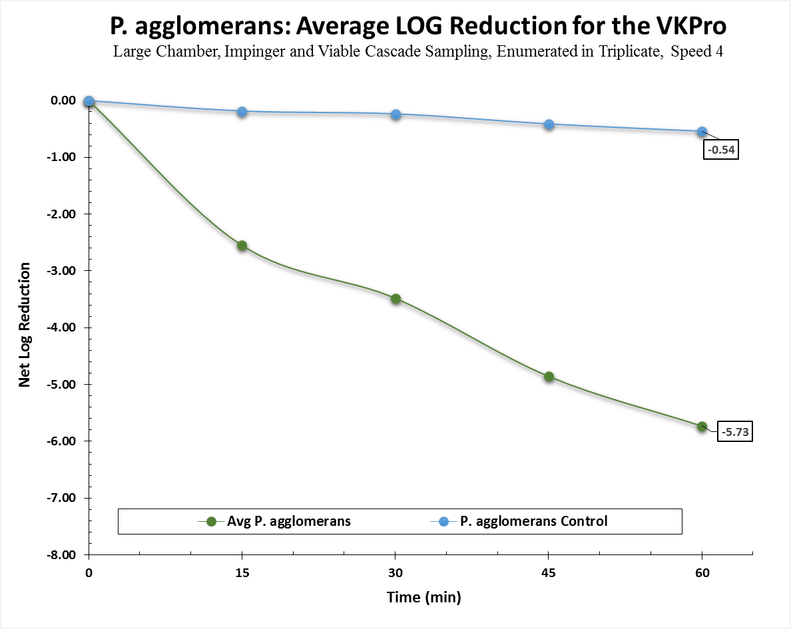
Figure 5A: Average LOG Reduction for P. Agglomerans Trials with Control Trial Data

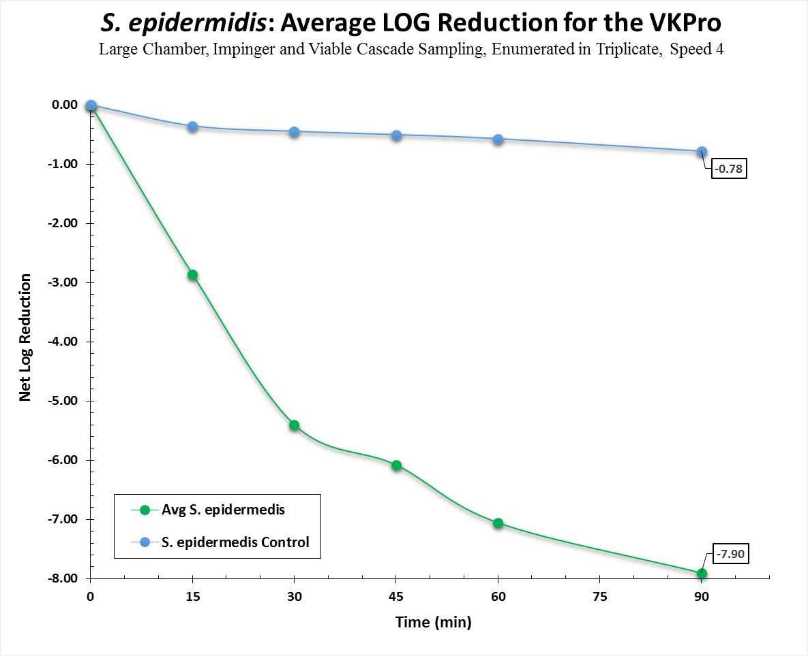
Figure 6A: Average LOG Reduction for P. Agglomerans Trials with Control Trial Data

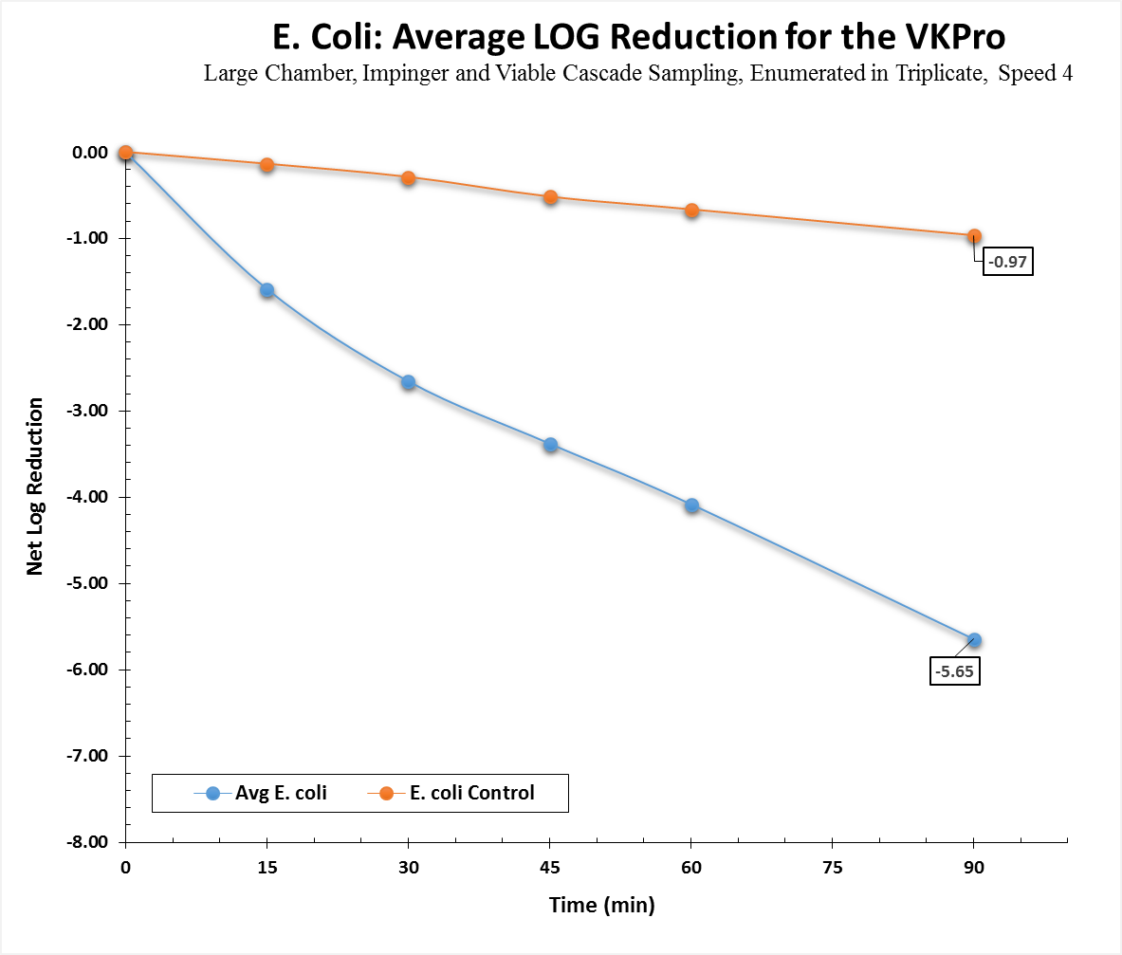
Figure 7A: Average LOG Reduction for E. Coli Trials with Control Trial Data

APPENDIX B: Individual Trials Raw Data

Figure 1B: Raw Plate Counts for S. epidermidis Control Trial

Figure 2B: Raw Plate Counts for S. epidermidis Trial 1

Figure 3B: Raw Plate Counts for S. epidermidis Trial 2
Figure 4B: Raw Plate Counts for S. epidermidis Trial 3
Figure 5B: Raw Plate Counts for E. coli Control Trial
Figure 6B: Raw Plate Counts for E. coli Trial 1
Figure 7B: Raw Plate Counts for E. coli Trial 2
Figure 8B: Raw Plate Counts for E. coli Trial 3
Figure 9B: Raw Plate Counts for A. brasiliensis Control Trial

Figure 10B: Raw Plate Counts for A. brasiliensis Trial 1

Figure 11B: Raw Plate Counts for A. brasiliensis Trial 2
Figure 12B: Raw Plate Counts for A. brasiliensis Trial 3
Figure 13B: Raw Plate Counts for B. subtilis Control Trial

Figure 14B: Raw Plate Counts for B. subtilis Trial 1
Figure 15B: Raw Plate Counts for B. subtilis Trial 2
Figure 16B: Raw Plate Counts for B. subtilis Trial 3
Figure 17B: Raw Plate Counts for MS2 Control Trial

Figure 18B: Raw Plate Counts for MS2 Trial 1
Figure 19B: Raw Plate Counts for MS2 Trial 2
Figure 20B: Raw Plate Counts for MS2 Trial 3
Figure 21B: Raw Plate Counts for Phi X Control

Figure 22B: Raw Plate Counts for Phi X Trial 1
Figure 23B: Raw Plate Counts for Phi X Trial 2
Figure 24B: Raw Plate Counts for Phi X Trial 3
Appendix C: Calculations

To evaluate the viable aerosol delivery efficiency and define operation parameters of the system, calculations based on (theoretical) 100% efficacy of aerosol dissemination were derived using the following steps:

- Plating and enumeration of the biological to derive the concentration of the stock suspension (C_{s}) in pfu/mL or cfu/mL, or cfu/g for dry powder.
- Collison 24 jet nebulizer use rate (R_{neb}) (volume of liquid generated by the nebulizer/time) at 28 psi air supply pressure = 1.0 mL/min.
- Collison 24 jet Generation time (t) = 20 or 30 minutes, test dependent.
- Chamber volume (V_{c} ) = 15,993 Liters
Assuming 100% efficiency, the quantity of aerosolized viable particles (V_{P}) per liter of air in the chamber for a given nebulizer stock concentration (C_{s}) is calculated as:
Nebulizer:
Plating and enumeration of the biological to derive the concentration of the dry powder (C_{p}) in cfu/g.
- Eductor use rate (M _{p}) (Mass of powder generated by the eductor in grams)
- Chamber volume (V_{c} ) = 15,993 Liters
Assuming 100% efficiency, the quantity of aerosolized viable particles (V_{P}) per liter of air in the chamber for a given dry powder stock concentration (C_{p}) is calculated as:
Eductor:
AGI – 30 impinger or 47mm filter collection calculation:
- Viable aerosol concentration collection (C_{a}) = cfu or pfu/L of chamber air.
- Viable Impinger concentration collection (C_{Imp}) = cfu or pfu/mL from enumeration of impinger sample or filter sample.
- Impinger sample collection volume (I_{vol}) = 20 mL collection fluid/impinger, or extraction fluid for filter.
- AGI–30 impinger or filter sample flow rate (Q_{imp}) = 12.5 L/min.
- AGI–30 impinger or filter sample time (t) = 5 or 10 minutes, test dependent.
For viable impinger or filter aerosol concentration collection (C_{a}) = cfu or pfu/L of chamber air:

The aerosol system viable delivery efficiency (expressed as %) is:



