‘Walk-Thru’ Developed as the World’s First by H PLUS Yangji Hospital Evolved to ‘Walk-Thru 3.0’

- H PLUS Yangji Hospital to hold ‘Walk-Thru Special Exhibition’ by participating in K-HOSPITAL FAIR at COEX (Oct. 21 – Oct. 23)
- Walk-Thru, the icon of K-quarantine, evolved again with an automated system and increased size to minimize the risk of infection
- ‘One-stop infection safety and prevention system’ established with Walk-Thru 3.0 and hospital access control system

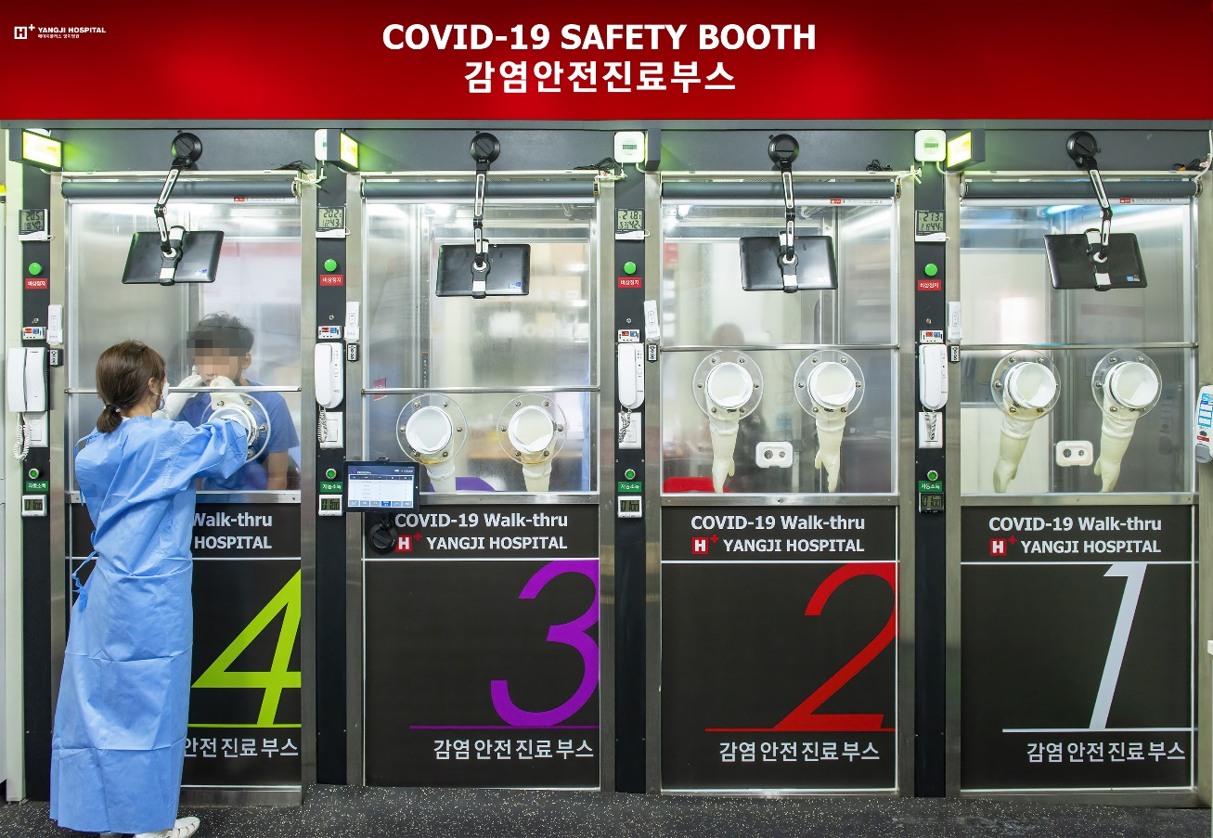
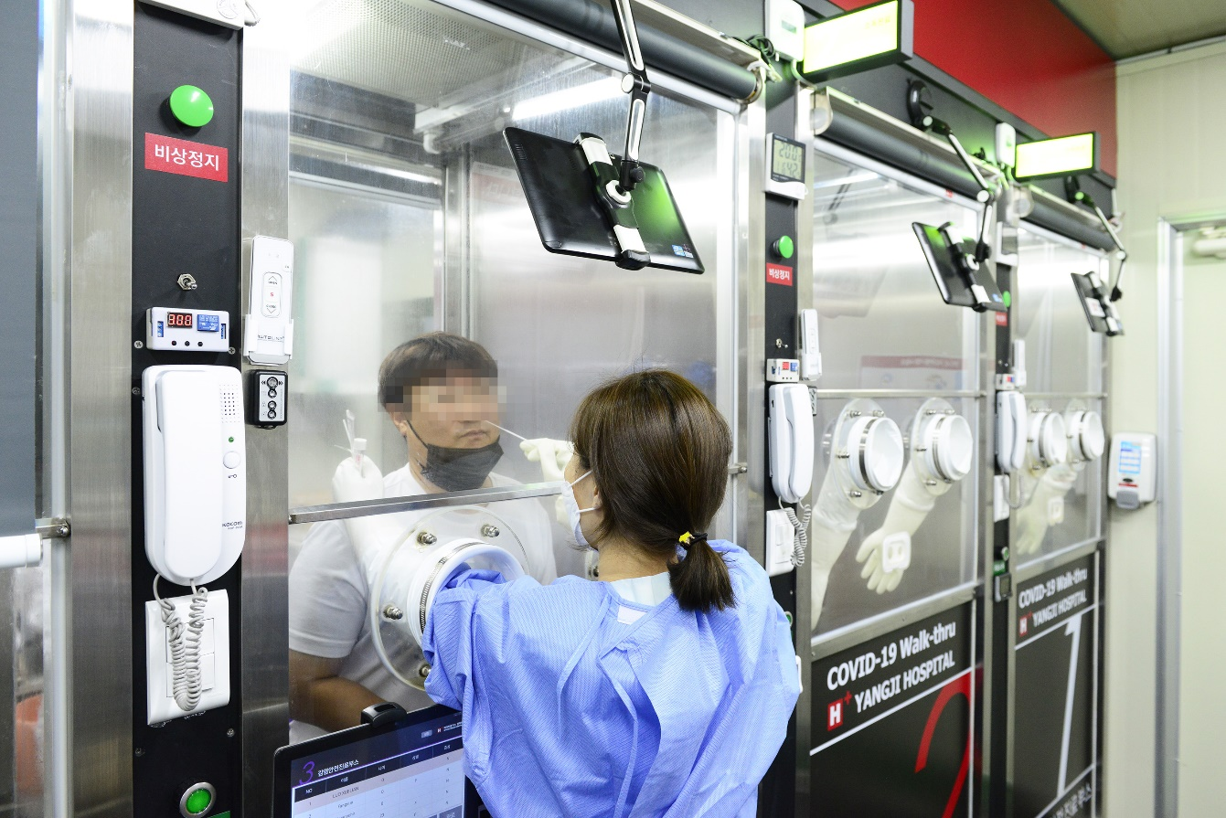
[Photo Caption: H PLUS Yangji Hospital’s Walk-Thru 3.0 further increases patient safety and convenience as the booth size became larger in width and length (900mm) than the 2.0 version (700mm) so as to minimize the risk of secondary infection inside the booth.]

SEOUL, South Korea--(October 16, 2020)-- Walk-Thru (COVID-19 Safety Booth), a walk-through screening booth developed by H PLUS Yangji Hospital (Director: Kim Sang-il) as the world’s first in March, has evolved again with the application of an automated system.

Walk-Thru 3.0 will be unveiled at the ‘Walk-Thru Special Exhibition’ of K-HOSPITAL FAIR 2020, which will be held in COEX, Seoul from October 21 to October 23 under the theme of “post COVID-19 era and medical service of the future.” ‘Ilsacheolli,’ an intelligent ‘non-contact’ access control system recently introduced by H PLUS Yangji Hospital, will also be on display.

H PLUS Yangji Hospital, a leader of K-quarantine, completed its COVID-19 quarantine system by developing ‘HOPE,’ a kiosk-type program to check the history of visits to infected countries as the first in Korea in February, and, subsequently, the ‘intelligent non-contact hospital access control system’ and ‘Walk-Thru 3.0.’

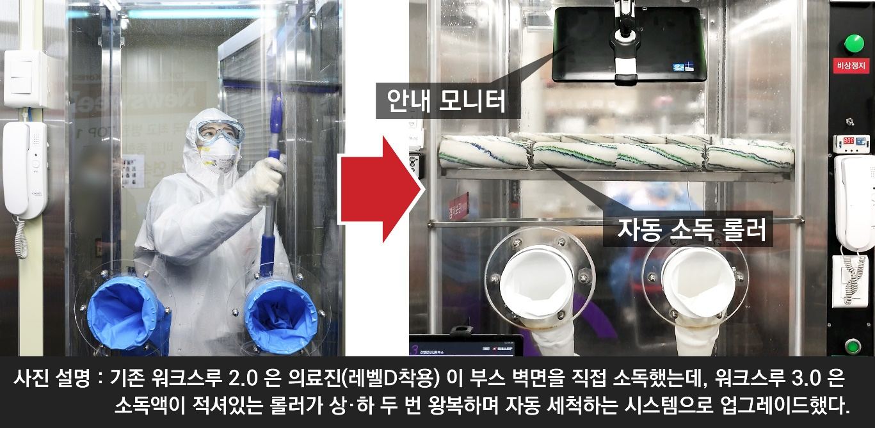
[Photo Caption: For the existing Walk-Thru 2.0, the medical staff (with level D PPE) had to disinfect the booth walls in person. Walk-Thru 3.0, however, has been upgraded with an automatic cleaning system where a roller saturated with disinfectant wipes each wall by moving up and down the wall twice.]

The first strength of H PLUS Yangji Hospital’s Walk-Thru 3.0 is that it provides a safer screening environment as it is equipped with an automated system to minimize the risk of cross-contamination between patients and the medical staff. In the past, medical personnel had to disinfect the screening booths in person. Walk-Thru 3.0, however, can be operated without the presence of medical personnel inside and is equipped with an automated system to provide information on the screening process and even disinfect the booths. The medical staff only need to press buttons on a tablet PC for the respective functions in their designated zone. When a button for the disinfecting function is pressed, a roller saturated with disinfectant (installed on each of the four walls of a booth) thoroughly disinfects the walls of a booth by rolling up and down each wall. In addition, as a booth has a built-in refrigerator for specimens, the collected specimens can be stored directly in the refrigerator.

The second strength is that Walk-Thru 3.0 provides a safer screening environment to patients. A negative-pressure environment is maintained inside a booth throughout the screening process and patients, after getting their specimens collected, are required to stay inside a booth for one minute with a mask on before leaving the booth. A patient is allowed to leave a booth after the virus, if the patient is infected with COVID-19, is removed by more than 99.9%. This is a measure to prevent the virus leak while a patient leaves a screening booth.

There is also a monitor installed inside a booth that provides information on the COVID-19 screening process in order to lower the anxiety of patients while they wait to be screened. The CCTV monitoring system helps in successful communication between the medical staff and patients. In addition, the booth size has become larger. To minimize the risk of secondary infection inside a booth and to improve patients’ safety and convenience, the width and length of a Walk-Thru 3.0 booth have been increased to 900mm, which is larger than those of the previous version (700mm).

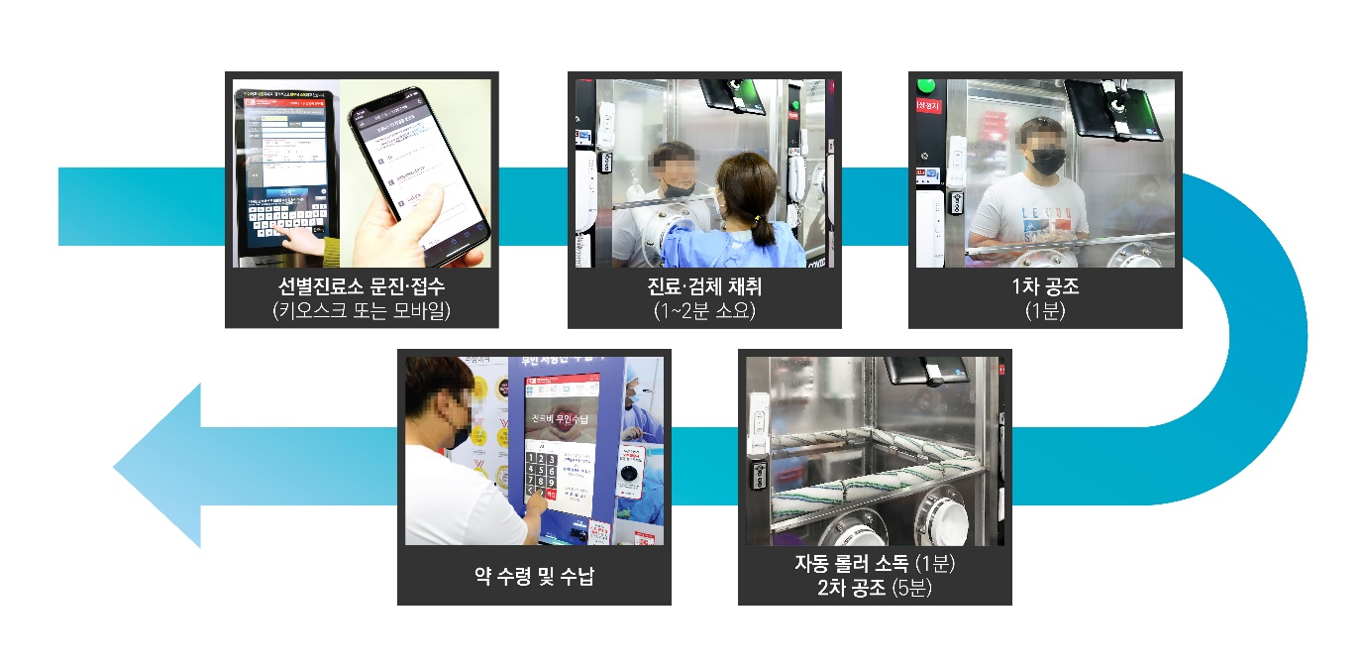
In the Walk-Thru 3.0 screening center, a patient receives medical examination and requests for screening through a kiosk or by using a mobile device. Then, after the screening is performed (for 1 – 2 minutes), the first air conditioning (for 1 minute) (negative pressure, air circulation) and automatic roller disinfection (for 1 minute) take place. The process is finished with the second air conditioning (for 5 minutes). Throughout this process, any contact between patients and between patients and the medical staff is limited.

Ilsacheolli, a Speed Gate-based intellectual video analysis solution that will be on display together with Walk-Thru 3.0 at the special exhibition, is a non-contact automated system aimed at assisting in safe hospital access. When a visitor fills out a questionnaire (using a mobile device or kiosk) and scans a QR code issued on the gate, the monitor camera swiftly detects the visitor’s face for a mask and body temperature to prevent infection among visitors.

H PLUS Yangji Hospital’s Walk-Thru screening center has been introduced by and is currently in operation at Massachusetts General Hospital (MGH), a hospital affiliated with Harvard Medical School. H PLUS Yangji Hospital is continuously receiving inquiries about Walk-Thru from medical institutes abroad. In March – April, Walk-Thru made headlines across the world as around 50 major foreign newspapers in 20 countries including the Washington Post, National Geographic, NHK, ABC, and BBC gave coverage.

In addition, having entered into an agreement on the public use and development of the intellectual property for Walk-Thru with Korean Intellectual Property Office in April, H PLUS Yangji Hospital obtained the national brand designation of ‘K-Walk Thru.’ At the same time, H PLUS Yangji Hospital, as the only private general hospital, joined the ‘consultative group for international standardization of K-quarantine model’ led by Korean Agency for Technology and Standards, a subsidiary of the Ministry of Trade, Industry and Energy.

“We will take this special exhibition as an opportunity to continue improving our quarantine system, such as the Walk-Thru screening center, through R&D in order to ensure effective quarantine for COVID-19 and to prepare for the outbreak and proliferation of other infectious diseases in the future,” said Director Kim Sang-il of H PLUS Yangji Hospital. Director Kim added, “We will dedicate efforts to improving our infection prevention system and creating a safe hospital environment for our patients.”

Contacts
H PLUS Yangji Hospital
Park Sanghoo PR Director
+82-70-4665-9016
+82-10-6274-8771

※ Request for coverage
Walk-Thru 3.0 Demonstration
Date and time : October 21, 2020 10:00 am / 2:00 pm
Place : 3rd floor of COEX, Hall C, B19

