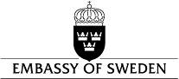
Seoul, 31 October 2017

Embassy Press Release

The 6th Swedish Film Festival

SEOUL Arthouse Momo, Wed. 1 – Tue. 7 November
BUSAN Busan Cinema Center, Fri. 3 – Thu. 9 November
GWANGJU Cinema Gwangju, Sun. 5 – Sat. 11 November

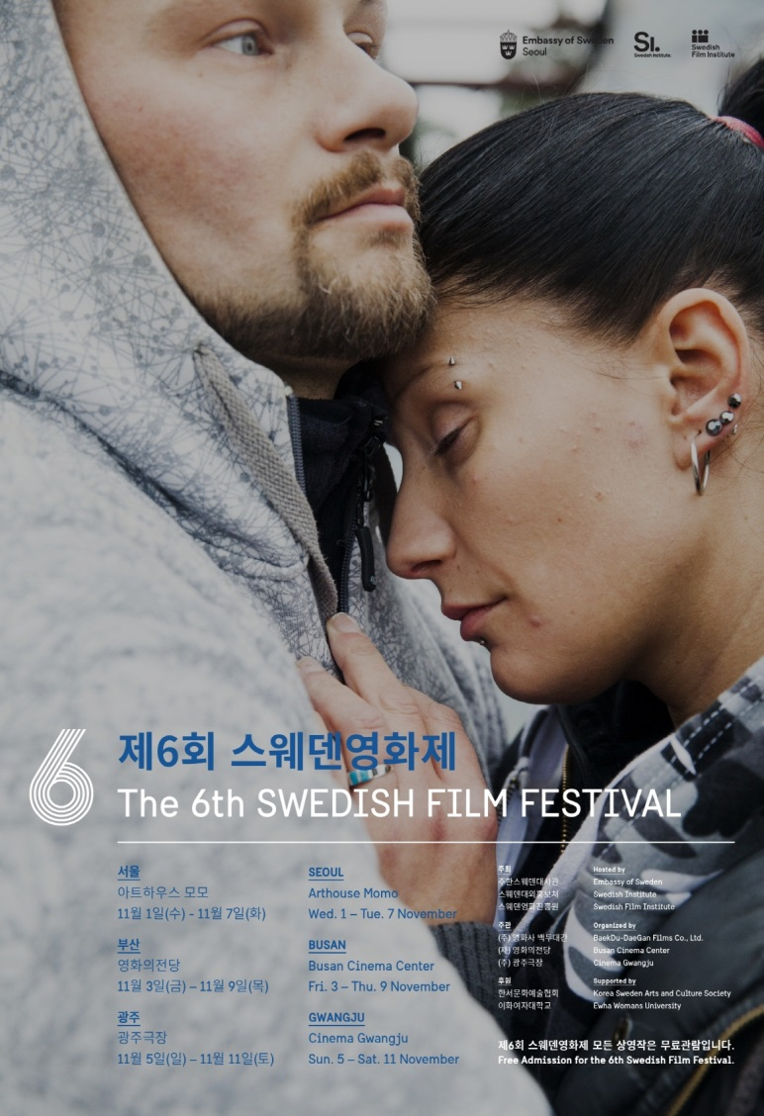

A cultural feast of heart-warming collection of Swedish cinema every autumn, the Swedish Film Festival (SFF) celebrates its 6th edition this year. Starting from SFF in Seoul at Arthouse Momo from November 1, this year’s festival will also take place in Busan from November 3, and in Gwangju from November 5 for one week respectively. The festival will screen 10 feature films under the theme of “Different but all right: We are family”. Already known as a country of tolerance and equality, Sweden is also one of the top recipients of refugees among European countries. This year’s SFF collection portrays various types of families from diverse ethnic and cultural origins, or even alternative or extended families.

Among this year’s selection, A Holy Mess is a comedy of multi-layered misunderstandings and conflicts happening in a Christmas family gathering, where conservative parents are worried about their son who wants to create a very special family with his same sex partner from an immigrant family. In Drifters, a female drug dealer living in a miserable condition meets an unexpected friend, a single mom also suffering from her broken family. Eternal Summer is a roadmovie of a desperate young couple on the run. A documentary film Martha & Niki is a story of two African-Swedish street dance champion girls. A fantasy film for all ages, Siv Sleeps Astray describes a magical, dream-like pre-Christmas night of a little girl who sleeps over at a new friend’s home.

If Siv Sleeps Astray is like a dream, The Girl, the Mother and the Demons is like a nightmare that depicts a schizophrenic single mom’s frustration and fear through the eyes of her little daughter who wants to save her mom from the demons. A young child who saves a parent is also the theme of the film Tsatsiki, Dad and the Olive War, where a Swedish boy Tsatsiki is struggling to save his Greek father’s family heritage: the hotel and the olive forest. The Girl Who Saved My Life is a powerful and touching documentary film about refugee stories and horrors of war in Syria. White People represents the harsh reality of illegal immigrants who face detention or deportation. Reflections is an impressive portrait of a mother-artist and a daughter-filmmaker, filmed by the daughter herself.

This year, the Swedish cinema has attracted a lot of attention on the global film scene. Bill Skarsgård, also familiar to SFF audience through Simple Simon, Simon and the Oaks, The Crown Jewels, is one of the most talked-about actors presently. He is from the famous Swedish actor family Skarsgård with Stellan the father, and brothers Alexander, Gustaf and Valter. Bill Skarsgård has captivated the worldwide audience with his impressive play as appalling Pennywise in the film It based on Stephen King novel. Swedish filmmaker Ruben Östlund received the Palme d’Or at this year’s Cannes Film Festival with The Square. The latest film of the Swedish director Tomas Alfredson (Let the Right One In) with Michael Fassbender, Snowman, will be released this winter, while the Oscar-winning Swedish actress Alicia Vikander is about to meet worldwide audience with her new film Tulip Fever.

The opening film of this year’s SFF is Drifters, awarded with 5 Guldbagge awards, the most prestigious Swedish film award, including the best screenplay and the best actress. The film is a social drama with an intense and deeply captivating look at a woman’s life and survival on the margins of society. The main actress Malin Levanon is coming to this year’s SFF to meet the Korean audience. Malin Levanon has already touched the audience with her play in the role of a single mom in the film Flocking, which won a Cristal Bear for best film at Berlin Film Festival. She appeared also in the film The Reunion (also seen at 4th SFF in 2015), which received FIPRESCI award at Venice Film Festival.

Another special guest from Sweden to this year’s Festival is Andreas Öhman., the Director of Eternal Summer. He directed the film Simple Simon, the story is about Simon with Asperger Syndrome and his brother Sam, starring the brilliant young Swedish actors such as Bill Skarsgård and Martin Wallström. The film was selected as the official Swedish entry for the Best Foreign Language Film at the 83rd Academy Awards. At this Festival, he presents his film Eternal Summer, a passionate and audacious road movie of a young couple on the run, through the breathtaking landscape of Northern Sweden with beautiful soundtracks. The main actor Filip Berg (Stockholm Stories, A Man Called Ove) was nominated with this role for the best actor at Guldbagge Awards.

The Swedish Film Festival, growing through the years not only in scale but also in diversity of program and events, will provide the Korean audience with an opportunity to experience various aspects of contemporary Swedish society. Through the message of tolerance and integration reflected in this year’s theme “Different but all right: We are family”, the audience may find much consolation and encouragement, valid for life in any culture.

Festival Official PR materials view & download link (http://bit.ly/2liYVY7 )

The Swedish Film Festival in Korea:

The Embassy of Sweden in Seoul annually organizes the Swedish Film Festival since 2012 to introduce Swedish contemporary films and trends to the Korean audience. The Embassy’s first film project was the special exhibition about Ingmar Bergman in 2011. Each year, the festival screens films that the Swedish Film Institute and the Swedish Institute consider being the best examples of current Swedish film. All films include Korean and English subtitles and tickets for all screenings are free of charge thanks to the support of the Korea Sweden Culture and Arts Society. The Swedish Film Festival is currently held in three major cities, Seoul, Busan and Gwangju.

Contacts:

SEOUL Arthouse Momo http://www.arthousemomo.com/ 02-747-7782
BUSAN Busan Cinema Center http://www.dureraum.org/ 051-780-6000
GWANGJU Cinema Gwangju http://cafe.naver.com/cinemagwangju 062-224-5858

Embassy of Sweden promotion@swedemb.or.kr 02-3703-3722

