BDACS plans to Join Circle’s Arc Layer 1 Blockchain as Stablecoin Partner

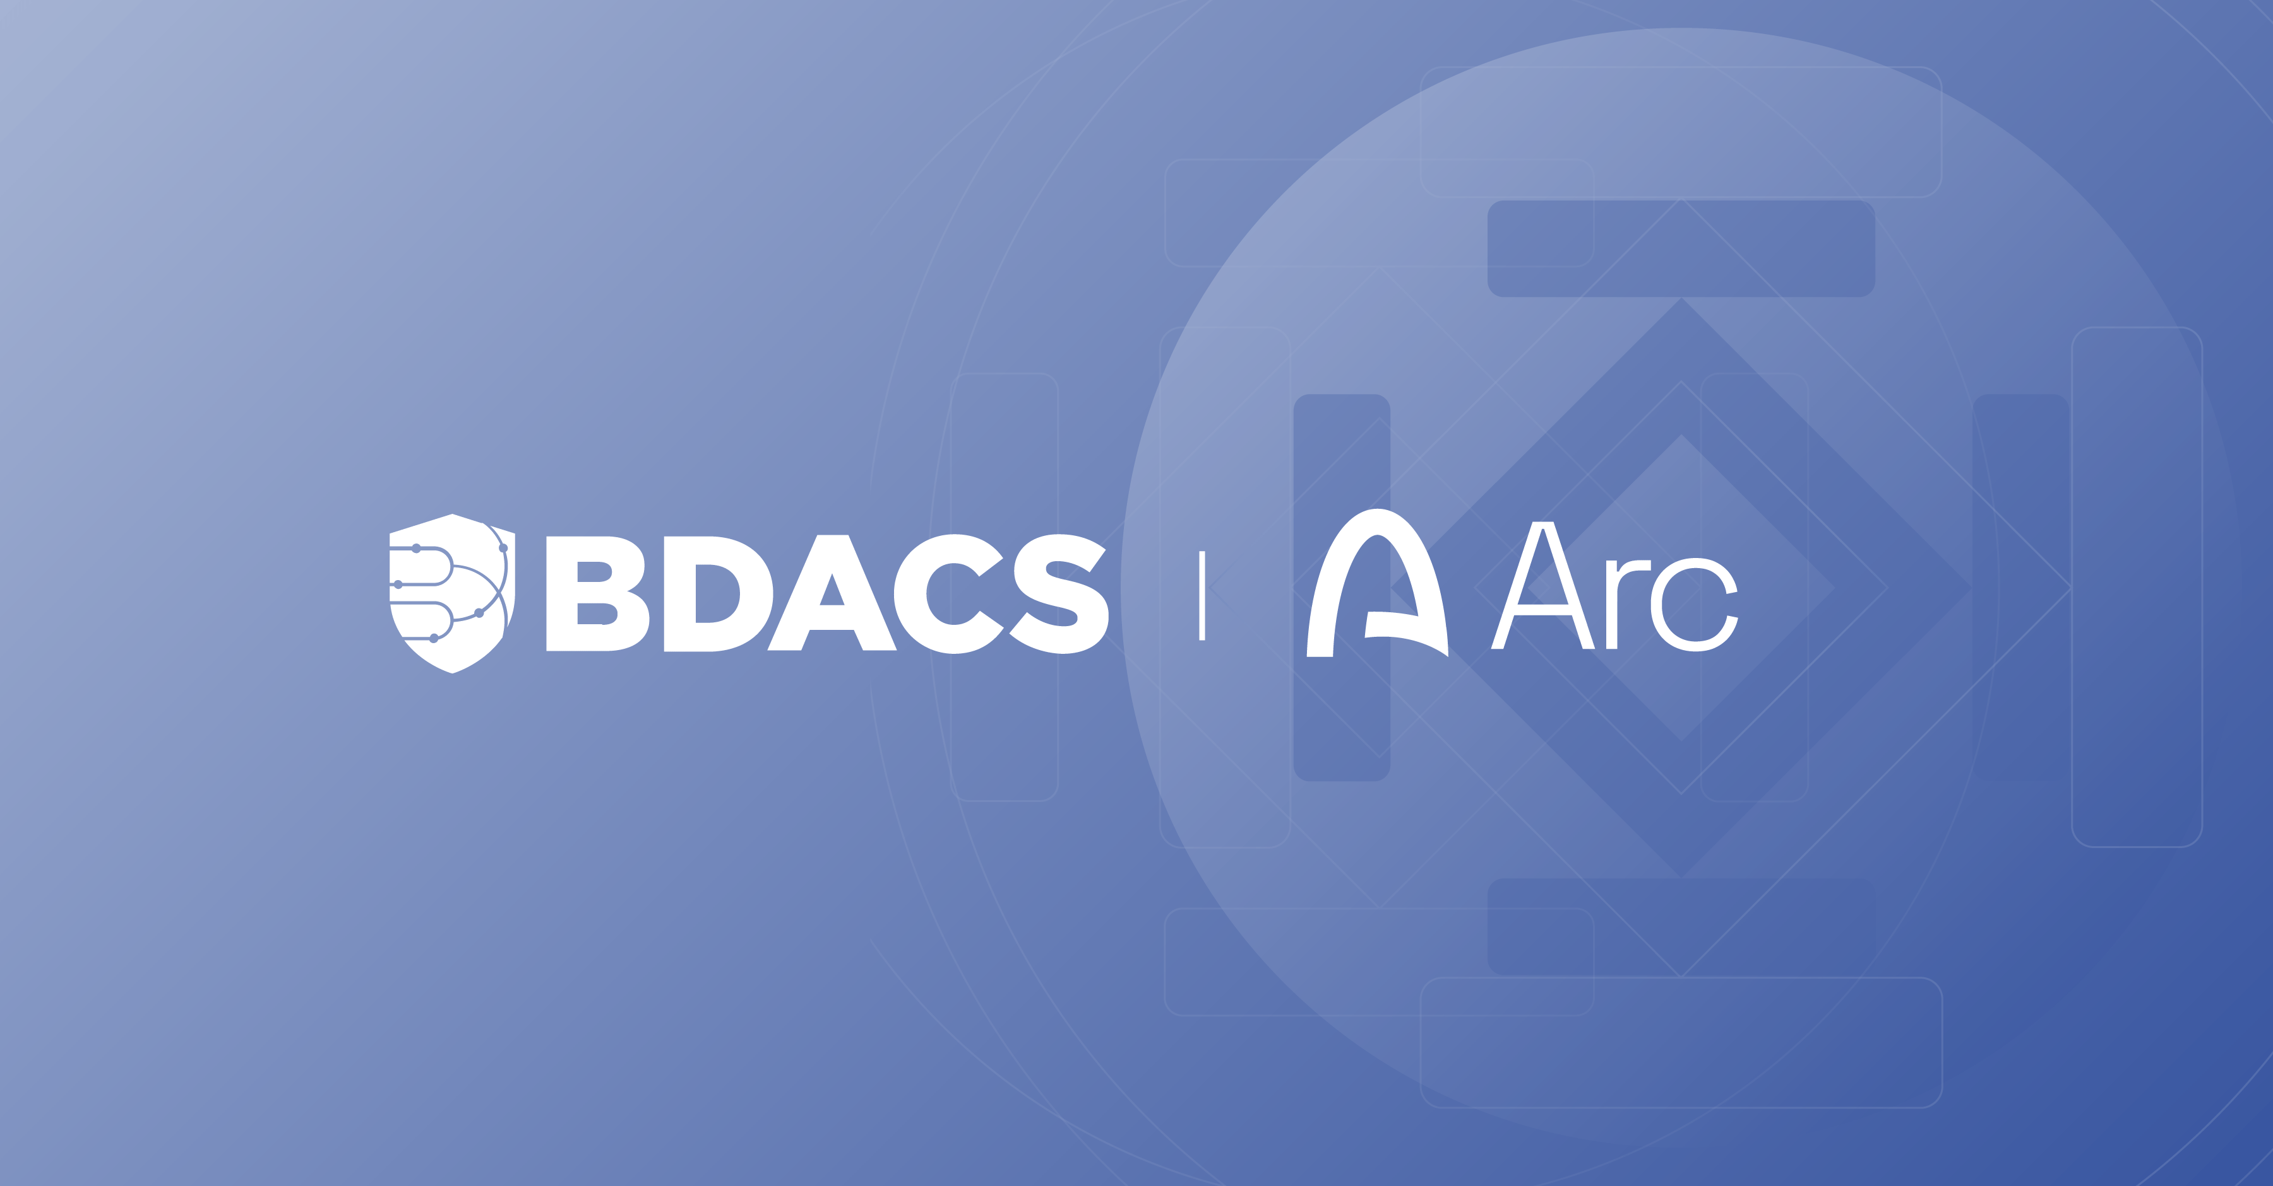

- BDACS plans to issue KRW1 on Arc, Circle’s Layer-1 blockchain
- BDACS and Circle to pilot onchain KRW1–USDC transactions and collaborate on establishing global stablecoin standards

SEOUL, South Korea (October 29, 2025) – BDACS, South Korea’s leading regulated digital asset infrastructure provider, has entered into a Memorandum of Understanding with Circle, the global fintech firm behind USDC, to bring KRW1, a fully backed Korean won stablecoin, to Arc, Circle’s newly launched Layer 1 blockchain - now in public testnet.

This collaboration marks a significant step in connecting Korea’s regulated financial ecosystem to the global digital asset economy.

BDACS plans to KRW1 on Arc, joining Circle’s growing network of trusted partners and becoming the first Korea-based issuer on the Arc blockchain.

“This is a major milestone in bringing Korean innovation to the global stage,” said Harry Ryoo, CEO of BDACS. “By deploying KRW1 on Arc, we’re building a gateway for Korean institutions and businesses to participate in a trusted, global stablecoin network.”

Through this collaboration, BDACS is further positioning Korea as a digital finance hub — integrating local regulatory strength with global blockchain infrastructure to accelerate adoption across payments, tokenized assets, and onchain capital markets.

